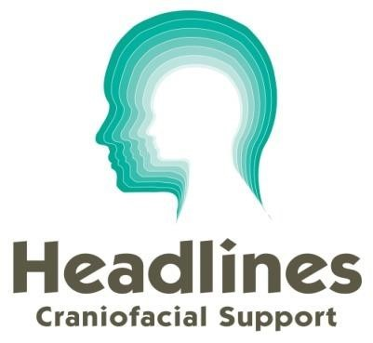
Registered charity no.)1058461/SCO50262
www.headlines.org.uk

Standing Order Authority to your Bank or Building Society

Your Bank or Building Society details (please print)

Bank Name ......................................................................................................................
Bank Address ...................................................................................................................
..........................................................................................................................................
..........................................................................................................................................
................................................................... Post Code ....................................................
Bank Sort Code
Bank Account No
Name of Account Holder(s)
(please print)

Payment details (please print)
Please pay £ ..................... every .................................
(in words) ..............................................................
commencing ……………………………………………………………
Debit my/our account accordingly until further notice in writing.

Payable to CAF Bank Ltd for the credit of
Account Name Headlines – The Craniofacial Support Group Account Sort Code 40-52-40
Account Number 00006948
Reference ...........................................
(please insert from data sheet)
Authorised Signatory(ies)
Date
IF YOU ARE A UK TAXPAYER, PLEASE ALSO COMPLETE A GIFT AID DECLARATION – THIS ALLOWS US TO CLAIM AN ADDITIONAL 20% ON YOUR DONATIONS FROM HMRC ( AND COSTS YOU NOTHING!)
Please return the completed form to Headlines, Arquen House, 4-6 Spicer Street, St Albans, AL3 4PQ or email it to info@headlines.org.uk
Registered charity no.)1058461/SCO50262
www.headlines.org.uk

GIFT AID DECLARATION

Boost your donation by 20p of Gift Aid for every £1 you donate.
Gift Aid is reclaimed by the charity from the tax you pay for the current tax year.
Your address is needed to identify you as a current UK taxpayer.

Please complete this form and return to:

Headlines Craniofacial Support , Arquen House,
4-6 Spicer Street, St.Albans AL3 4PQ
or email it to: contact@headlines.org.uk

Name (please print):

Address:

Post Code: Tel:

Email:

I/we wish to Gift Aid my donation of £ and any donations I make in the future or have made in the past 4 years to Headlines Craniofacial Support.

I am a UK taxpayer and understand that if I pay less Income Tax and/or Capital Gains Tax than the amount of Gift Aid claimed on all my donations in that tax year it is my responsibility to pay any difference.

Signature: Date:

NB: You will need to notify Headlines if you:

- want to cancel this declaration
- change your name or home address
- no longer pay sufficient tax on your income and/or capital gains

If you pay Income Tax at the higher or additional rate and want to receive the additional tax relief due to you, you must include all your Gift Aid donations on your Self-Assessment tax return or ask HM Revenue and Customs to adjust your tax code.

UPDATED 2024

